AS919611- Develop a prototype considering fitness for purpose in the broadest sense

# Brief

Recommender systems are most commonly recognised as playlist generators for video and music services like Netflix, YouTube and Spotify, product recommenders for services such as Amazon, or content recommenders for social media platforms such as Facebook and Twitter.

“In October, 2006 Netflix released a dataset containing 100 million anonymous movie ratings and challenged the data mining, machine learning and computer science communities to develop systems that could beat the accuracy of its recommendation system, Cinematch (Bennett & Lanning, 2007).

Given a dataset of movies, users and their ratings, you are to create a recommender system.

You must:

* Be able to add a user
* Search for a movie
* Rate a movie
* Recommend a movie specific to the user based on their rating
* Have a GUI
* Use persistent storage (i.e. store the data in a file)

# Materials, Tools and techniques

## Materials in the context of programming are programming languages. The languages that I will consider are: Python, Scratch, JavaScript and HTML5/CSS & database. In the table below I have evaluated the positives and negatives of each language for this prototype.

|  |  |  |
| --- | --- | --- |
| Language | Positives | Negatives |
| Python (Picked) | I know how to program everything I need in it.  Lots of online resources like Stack Overflow that I can use if I need help.  Everyone else in this class and the other DTC class knows it so it is easy to get specific help for things that websites doesn’t have an answer to.  It is installed on school computers. | Although I know how to program a GUI in it, it is hard to do.  Hard to transfer to other platforms (e.g. android, apple, smart TV). |
| Scratch | Easy to learn how to use.  GUIs are incredibly easy to write in it. | I would have to learn how to use it to a more advanced level than I currently do.  Hard to write complicated programs in because it does not have functions. |
| Java | Could transfer the program to different platforms (e.g. android, apple, smart TV).  Its GUI design would work well for this project, making it easier for me to learn and use it. | I have no idea how to program in Java so I would have to learn fast to be able to complete the prototype in time. |
| HTML5/CSS | I could easily use a MySQL database to store the movies and reviews easily.  I know how to create a nice GUI with CSS.  Since it would be a website, it could be accessed from anywhere and on a multitude of devices and platforms. | I haven’t programmed in HTML5 or CSS in a while so I would have to refresh my memory.  I haven’t programmed something close to this complicated in HTML5 so I would have to learn how.  I would have to manage the database as well as the website. |

Justification: I picked Python as the programming language I will be using for my prototype.

## Tools in the context of programming are the programs I will use. The IDEs I will consider using are: IDLE, Sublime and notepad++. The other programs I will use are: Microsoft Word (Documentation), Google Chrome (Help with the program), and OneDrive. In the table below I have evaluated the positives and negatives of each IDE for this prototype.

|  |  |  |
| --- | --- | --- |
| IDE | Positives | Negatives |
| IDLE (Picked) | I am very familiar with it.  It is already installed on school computers.  It is the default IDE that comes with Python which is convenient because it automatically opens when I open python | No way to see what line number something is on unless you click on that line. |
| Sublime | It is already installed on school computers.  There are line numbers on the left which make it easy to navigate and locate errors | Annoying to use on the school computers since it’s not the default IDE. |
| Notepad++ | It is already installed on school computers.  There are line numbers on the left which make it easy to navigate and locate errors | I am not familiar with notepad++  Annoying to use on the school computers since it’s not the default IDE. |

Justification: I picked Python as the programming language I will be using for my prototype.

## Techniques in the context of programming prototyping methods. The methods that I will be using are: Wizard of Oz, Storyboarding, Kanban and a Burndown chart. In the table below I have evaluated the different methods.

|  |  |
| --- | --- |
| Technique | Evaluation |
| Wizard of Oz | Wizard of Oz prototyping is a prototyping method where the developer makes a rudimentary emulation of the final outcome, often using everyday objects (pen and paper). The user may or may not be aware that they are using a Wizard of Oz prototype and not the real thing, depending on the functionality of the prototype.  Wizard of Oz is used to give the developer a sense for how users will interact with their final outcome, which gives them a chance to change core aspects before even starting the program.  H:\13DTC\AS91611\wizard_of_oz_prototyping.jpgWizard of Oz would be a good method to use for my program since it will help me find how users navigate around my program, and therefore help me construct a quality GUI that feels smooth and good to use. |
| Storyboarding | Storyboarding bruh bruh its like wizard of oz but theres no interaction.  H:\13DTC\AS91611\storyboard.jpg |
| Kanban |  |
| Burndown Chart |  |

# Initial Stakeholder Feedback

## Storyboard Prototype Initial Feedback

|  |  |
| --- | --- |
| Person | Feedback |
| Ben Koepele | I like how it works, solid idea. I particularly like how it tells you the percentages. |
| Tavish Dempster | Good initial program and GUI, I like the look of it. |
| Ronan Comeskey | I like how it is all on one screen so the user can see all GUI elements at the same time. I would like to see some information labels that tells the user what movie is selected and what rating they just made to make it clearer. |
| Mr. Ny | This is good for an initial state, however you should develop on it more in later iterations. |

## Are there any other important features I should add to my program?

|  |  |
| --- | --- |
| Person | Feedback |
| Ben Koepele | I think having a ‘generate recommendations’ buttons would be good. It’s good to keep it simple though because you shouldn’t have too many crazy things happening. |
| Tavish Dempster | I think that you should be able to choose when you get the recommendations rather than it being an automatic process. Also maybe clear the entry box once the user has rated the movie. Otherwise they will have to manually delete the things that are in the box which makes the process less streamlined. |
| Ronan Comeskey | See above |
| Mr. Ny | How it is now is fine. |

# First Iteration

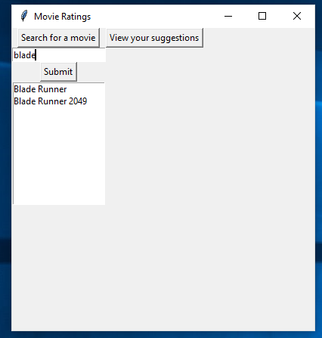For my first iteration, I have created a GUI that 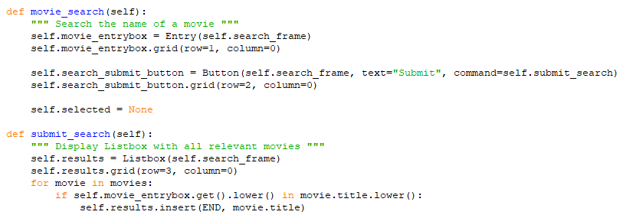lets the user search for a movie, then returns relevant movies. It uses a listbox to display the searched movies.

Although it doesn’t do anything, I created a button called “View your suggestions” that shows the user their recommended movies. I did this because multiple stakeholders requested it not be automatic.

In the next iteration, I will let the user rate selected movies. In future iterations I will make the suggestions button actually work, add labels and clean up the look of the GUI.

## Do you like how my search function works?

|  |  |
| --- | --- |
| Person | Feedback |
| Ben Koepele | I like how you can search anything and it will come up with all the movies that contain what you searched, like if you search “s” it will come up with every movie containing an s in the title. I also like how you used a listbox. |
| Tavish Dempster | It’s good, clean. I think you should add a label to let you know what you have selected once you select a movie. |
| Ronan Comeskey | I like how it works but I think you need to add labels to let the user know what is going on. |
| Mr. Ny |  |

# Second Iteration

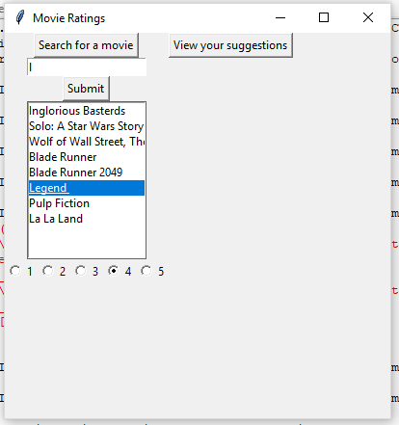For this second iteration, I added a rate method, which allows the user to rate the selected movie 1-5 using radio buttons. I used a method that I [found online](https://stackoverflow.com/questions/15672552/python-tkinter-listbox-get-active-method), which finds which item in the listbox the user has selected.

During the proccess of coding the rating buttons, I received stakeholder feedback from T. Dempster and R. Comesky to use radiobuttons instead of regular buttons.

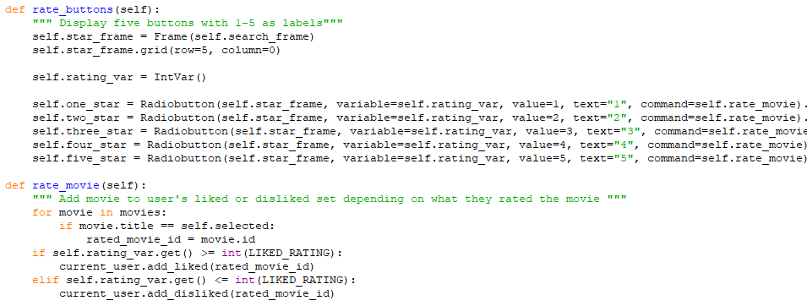In the next iteration, I will make the suggestions button actually work and add some labels to let the user know what is happening, as per my stakeholder feedback.

## Do you like how my rate function works?

|  |  |
| --- | --- |
| Person | Feedback |
| Ben Koepele | What Tavish said, but also you should explore adding a bilingual option to your program to make sure you are not marginalising the Maori people. |
| Tavish Dempster | You should have a submit button for when you rate so if people miss click, it’s all good. |
| Ronan Comeskey | I think you should add a label or something to let you know what movie you have selected and are currently rating. You should also add a submit button for when you are rating because it isn’t clear if your rating has gone through. I also like how the radiobuttons reset when you click on a new movie. |
| Mr. Ny |  |

# Third Iteration

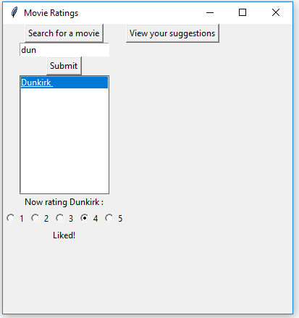For this second iteration, I added a rate method, which allows the user to rate the selected movie 1-5 using radio buttons. I used a method that I [found online](https://stackoverflow.com/questions/15672552/python-tkinter-listbox-get-active-method), which finds which item in the listbox the user has selected.

During the proccess of coding the rating buttons, I received stakeholder feedback from T. Dempster and R. Comesky to use radiobuttons instead of regular buttons.

In the next iteration, I will make the suggestions button actually work and add some labels to let the user know what is happening, as per my stakeholder feedback.

## Do you like how my rate function works?

|  |  |
| --- | --- |
| Person | Feedback |
| Ben Koepele | What Tavish said, but also you should explore adding a bilingual option to your program to make sure you are not marginalising the Maori people. |
| Tavish Dempster | You should have a submit button for when you rate so if people miss click, it’s all good. |
| Ronan Comeskey | I think you should add a label or something to let you know what movie you have selected and are currently rating. You should also add a submit button for when you are rating because it isn’t clear if your rating has gone through. I also like how the radiobuttons reset when you click on a new movie. |
| Mr. Ny |  |